ASSIGNMENT – 10

NAME: kavali saikarthik

HT.NO: 2403A52043

BATCH: 03

Task-1:

Syntax and Error Detection  
Task: Identify and fix syntax, indentation, and variable errors in the  
given script.  
def add_numbers(a, b)  
result = a + b  
return reslt  
print(add_numbers(10 20))  
Expected Output:  
• Corrected code with proper syntax (: after function, fixed variable  
name, corrected function call).  
• AI should explain what was fixed

Prompt: Identify and fix syntax, indentation, and variable errors in the

given script.

def add_numbers(a, b)

result = a + b

return reslt

print(add_numbers(10 20)).

even expain the errors.

Code:

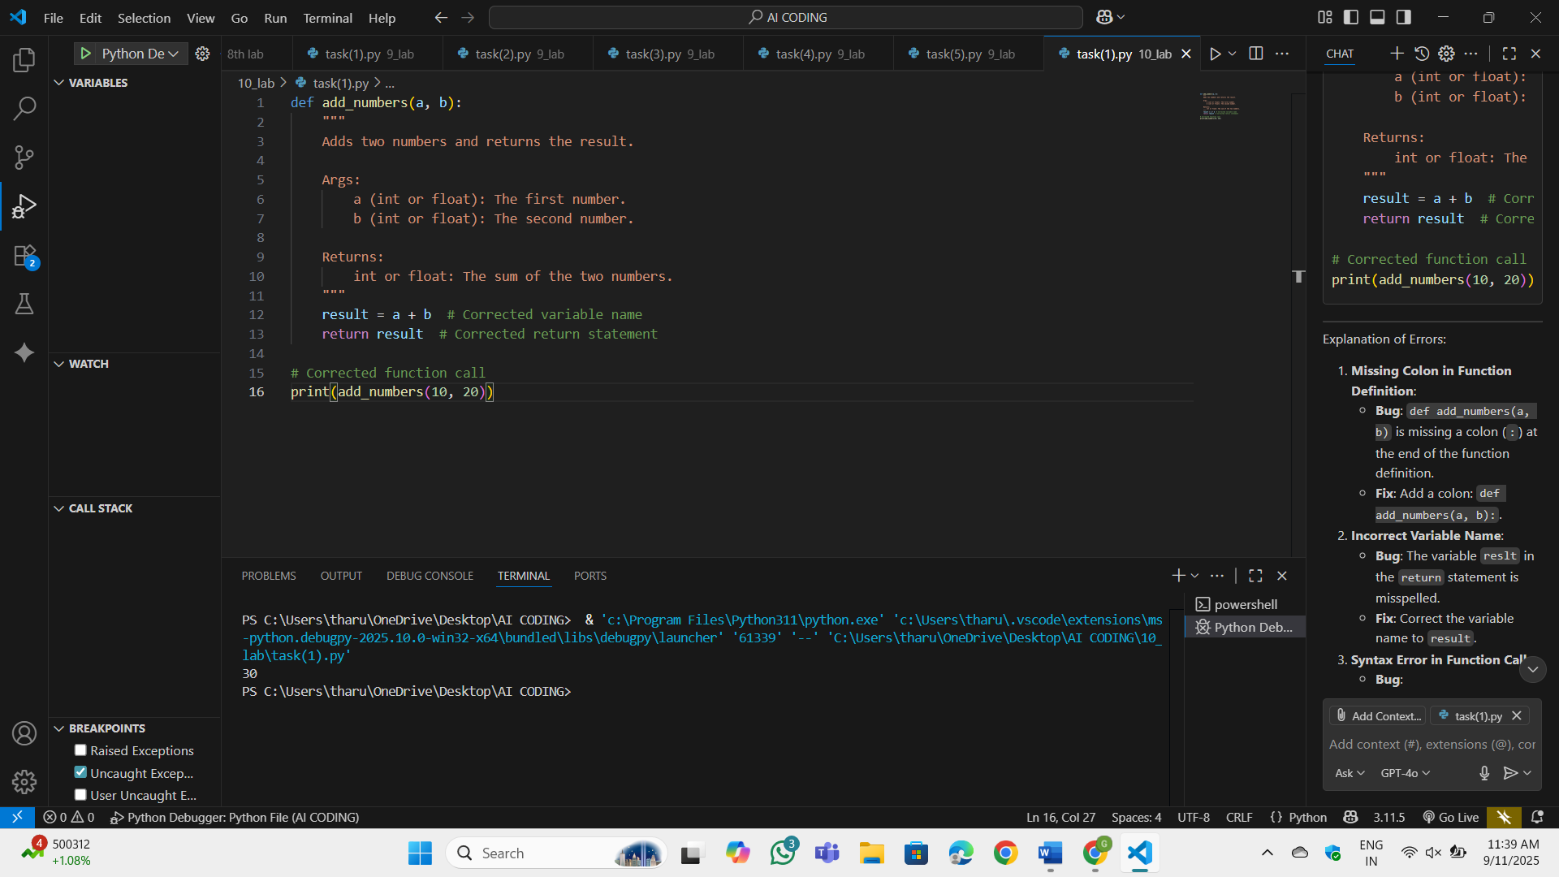

OP:



Observation: It has corrected the errors and even explained it.**Bug**: def add_numbers(a, b) is missing a colon (:) at the end of the function definition. **Fix**: Add a colon: def add_numbers(a, b):. **Bug**: The variable reslt in the return statement is misspelled. **Fix**: Correct the variable name to result. **Bug**: print(add_numbers(10 20)) is missing a comma between 10 and 20. **Fix**: Add a comma: print(add_numbers(10, 20)). **Bug**: The print statement has an extra closing parenthesis: print(add_numbers(10, 20)). **Fix**: Remove the extra parenthesis.

Task-2:

Logical and Performance Issue Review  
Task: Optimize inefficient logic while keeping the result correct.  
# buggy_code_task2.py  
def find_duplicates(nums):  
duplicates = []  
for i in range(len(nums)):  
for j in range(len(nums)):  
if i != j and nums[i] == nums[j] and nums[i] not in duplicates:  
duplicates.append(nums[i])  
return duplicates numbers = [1,2,3,2,4,5,1,6,1,2]  
print(find_duplicates(numbers))  
Expected Output:  
• More efficient duplicate detection (e.g., using sets).  
• AI should explain the optimization.

Prompt: Optimize inefficient logic while keeping the result correct.

def find_duplicates(nums):

duplicates = []

for i in range(len(nums)):

for j in range(len(nums)):

if i!= j and nums[i] == nums[j] and nums[i] not in duplicates:

duplicates.append(nums[i])

return duplicates numbers = [1,2,3,2,4,5,1,6,1,2].

print(find_duplicates(numbers)). use sets and give explaintion for correction

Code:

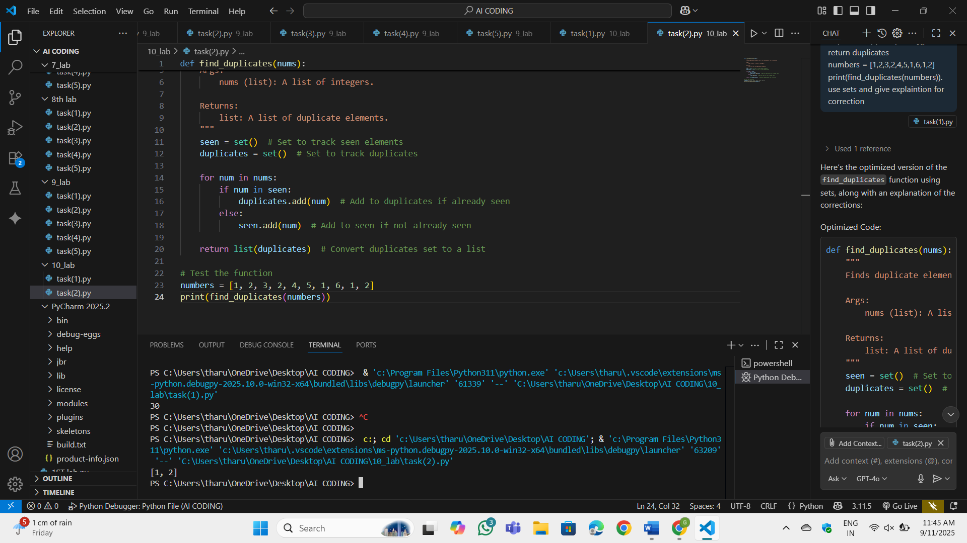

OP:



Observation:

**Bug**: The original code uses nested loops (for i in range(len(nums)) and for j in range(len(nums))), resulting in an **O(n²)** time complexity. **Fix**: Replaced the nested loops with a single loop and used sets to track seen elements and duplicates, reducing the time complexity to **O(n)**. **Bug**: The original code uses a list (duplicates) to store duplicates, which requires checking if an element is already in the list (nums[i] not in duplicates), making it inefficient. **Fix**: Used a set (duplicates) to store duplicates, as set lookups are faster (average **O(1)** time complexity). **Bug**: The original code checks i != j and compares every pair of elements, which is unnecessary. **Fix**: Simplified the logic by using a single loop. If an element is already in the seen set, it is added to the duplicates set. **Fix**: Converted the duplicates set to a list before returning, as the output format is expected to be a list.

Task-3:

Code Refactoring for Readability  
Task: Refactor messy code into clean, PEP 8–compliant, well-  
structured code.  
# buggy_code_task3.py

def c(n):  
x=1  
for i in range(1,n+1):  
x=x*i  
return x  
print(c(5))  
Expected Output:  
Function renamed to calculate_factorial.  
Proper indentation, variable naming, docstrings, and formatting.  
AI should provide a more readable version

Prompt: Refactor messy code into clean, PEP 8–compliant, well-structured code.

def c(n):

x=1

for i in range(1,n+1):

x=x*i

return x

print(c(5))

Function renamed to calculate_factorial. Proper indentation, variable naming, docstrings, and formatting

Code:

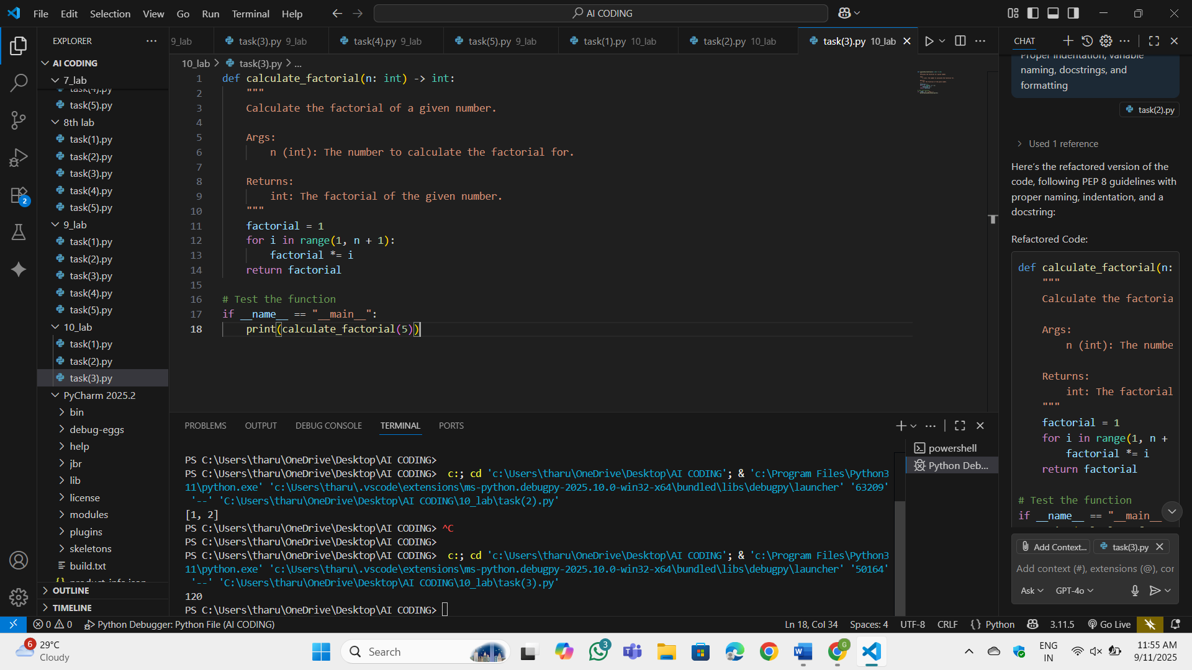

OP:



Observation: Renamed c to calculate_factorial to make the function name descriptive and meaningful. Renamed x to factorial for clarity. Added a Google-style docstring to describe the function's purpose, arguments, and return value. Ensured proper indentation and spacing.

Added type hints for the function argument and return value. Wrapped the test call in an if __name__ == "__main__": block to ensure the function is only executed when the script is run directly.

Task-4:

Security and Error Handling Enhancement  
Task: Add security practices and exception handling to the code.  
# buggy_code_task4.py  
import sqlite3  
def get_user_data(user_id):  
conn = sqlite3.connect("users.db")  
cursor = conn.cursor()  
query = f"SELECT * FROM users WHERE id = {user_id};" #  
Potential SQL injection risk  
cursor.execute(query)  
result = cursor.fetchall()  
conn.close()  
return result  
user_input = input("Enter user ID: ")  
print(get_user_data(user_input))  
Expected Output:  
Safe query using parameterized SQL (? placeholders).  
Try-except block for database errors.  
Input validation before query execution.

Prompt: Add security practices and exception handling to the code.  
import sqlite3  
def get_user_data(user_id):  
conn = sqlite3.connect("users.db")  
cursor = conn.cursor()  
query = f"SELECT * FROM users WHERE id = {user_id};" #  
Potential SQL injection risk  
cursor.execute(query)  
result = cursor.fetchall()  
conn.close()  
return result  
user_input = input("Enter user ID: ")  
print(get_user_data(user_input)).

Safe query using parameterized SQL (? placeholders). Try-except block for database errors. Input validation before query execution.

Code:

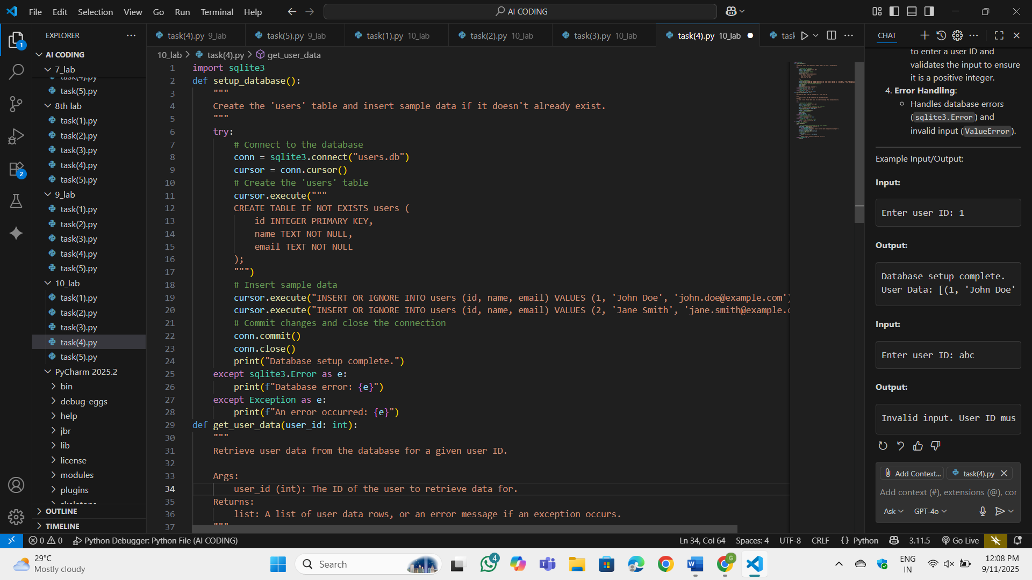

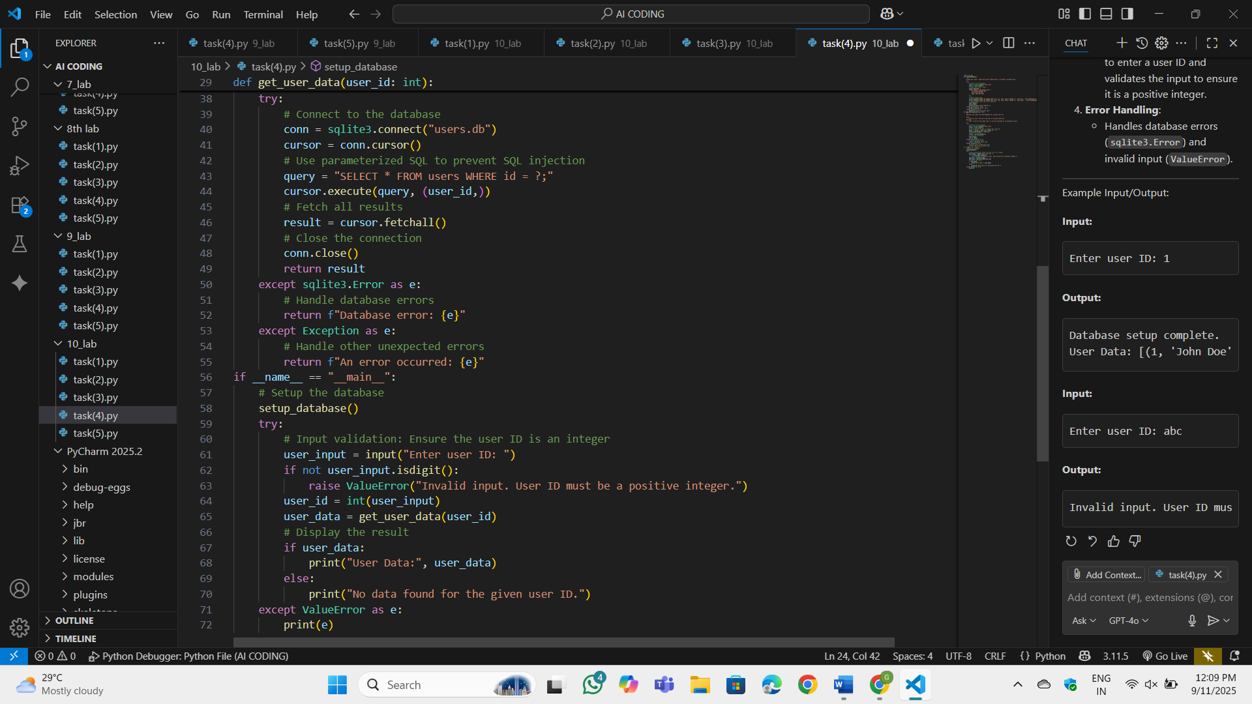

OP:

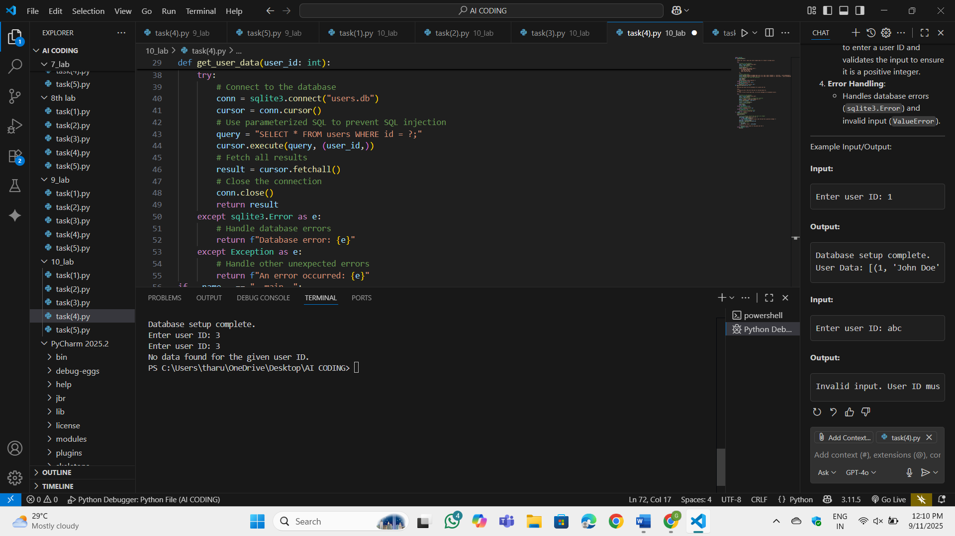

Observation:

This Python script is designed to manage a simple SQLite database for user data. It includes two main functions: `setup_database` and `get_user_data`. The `setup_database` function ensures that the database (users.db) is properly initialized. It creates a `users` table if it doesn't already exist and inserts sample data for testing purposes. This function uses the `CREATE TABLE IF NOT EXISTS` SQL statement to avoid duplicate table creation and the `INSERT OR IGNORE` statement to prevent duplicate entries. The `get_user_data` function retrieves user data for a given user ID using parameterized SQL queries (`?` placeholders) to prevent SQL injection attacks. It connects to the database, executes the query, fetches the results, and closes the connection. The script also includes robust error handling to manage database-related errors (`sqlite3.Error`) and unexpected exceptions. In the `if __name__ == "__main__":` block, the script first sets up the database and then prompts the user to enter a user ID. The input is validated to ensure it is a positive integer, and if valid, the `get_user_data` function is called to fetch and display the user data. If the user ID is invalid or no data is found, appropriate error messages are displayed. This script demonstrates best practices for database management, including input validation, parameterized queries, and proper resource handling.

Task-5:

Automated Code Review Report Generation  
Task: Generate a review report for this messy code.  
# buggy_code_task5.py

def calc(x,y,z):  
if z=="add":  
return x+y  
elif z=="sub": return x-y  
elif z=="mul":  
return x*y  
elif z=="div":  
return x/y  
else: print("wrong")  
print(calc(10,5,"add"))  
print(calc(10,0,"div"))  
Expected Output:  
AI-generated review report should mention:  
o Missing docstrings  
o Inconsistent formatting (indentation, inline return)  
o Missing error handling for division by zero  
o Non-descriptive function/variable names  
o Suggestions for readability and PEP 8 compliance

Prompt: Generate a review report for this messy code.

def calc(x,y,z):  
if z=="add":  
return x+y  
elif z=="sub": return x-y  
elif z=="mul":  
return x*y  
elif z=="div":  
return x/y  
else: print("wrong")  
print(calc(10,5,"add"))  
print(calc(10,0,"div"))  
include: Missing docstrings. Inconsistent formatting (indentation, inline return). Missing error handling for division by zero. Non-descriptive function/variable names. Suggestions for readability and PEP 8 compliance

Code:

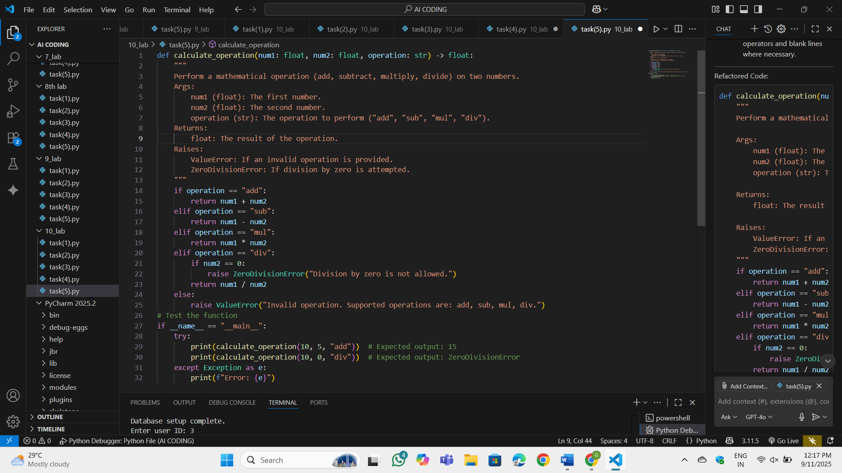

OP:

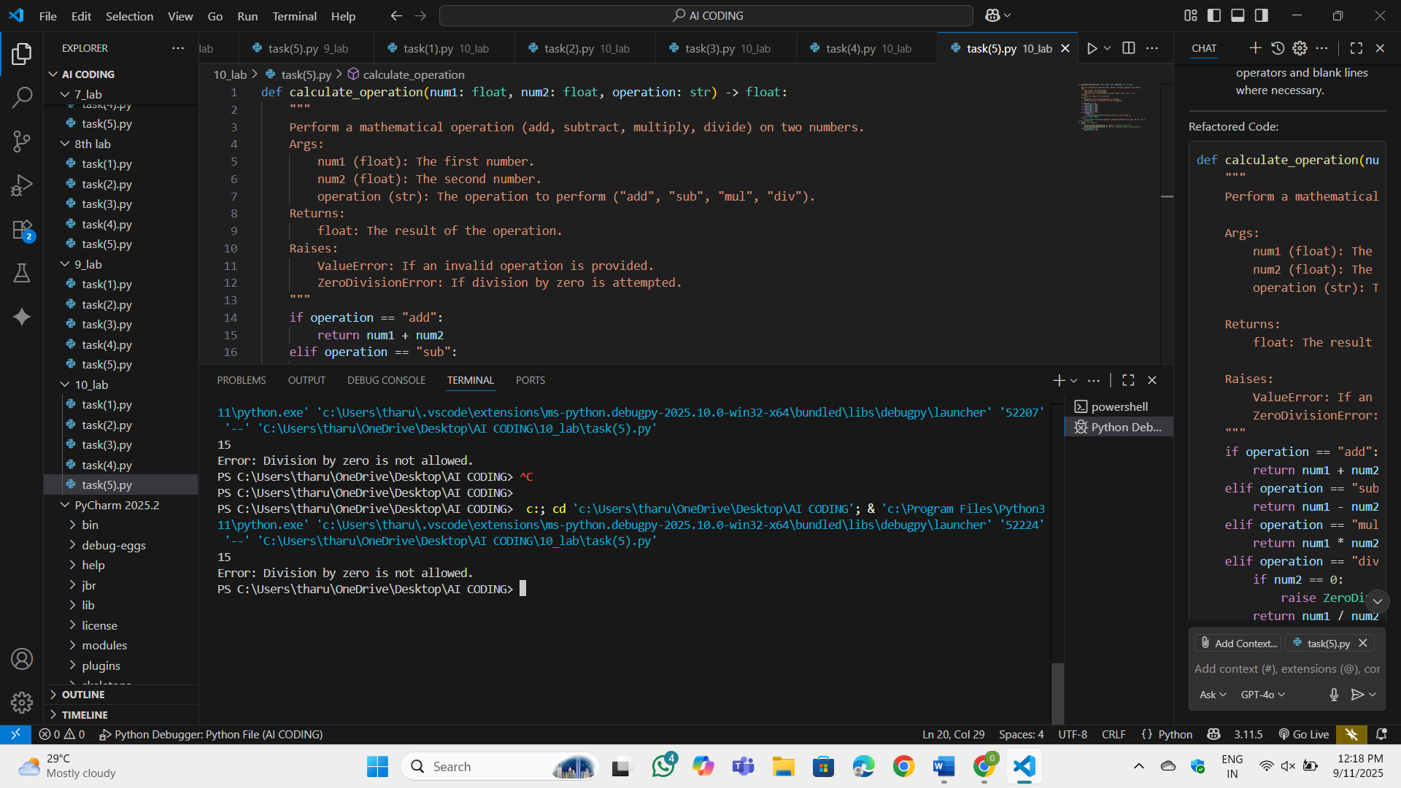

Observation:A detailed Google-style docstring was added to describe the function's purpose, parameters, return values, and exceptions. Indentation and formatting were made consistent. Removed inline returns for better readability. Added a check for division by zero and raised a ZeroDivisionError with a clear message. Renamed calc to calculate_operation and variables x, y, and z to num1, num2, and operation. Added spaces around operators and blank lines where necessary